Hardware and OOP Implementation

1 Introduction

This report contains the final versions of our system requirements and UML Class Diagram that we used to create our burglar alarm system. The requirements helped us to make sure the system does what is necessary for our casino scenario and the UML Diagram outlines the class structure for our C++ and Arduino code.

2 System requirements

These are our system requirements for the project:

- The system shall allow authorised staff to access the alarm control panel using facial recognition
  - The system shall use a built-in camera located inside the casino office to capture the user’s face when authentication is required to arm or disarm the system. (SA1) (F)
    - The system should be operable from a minimum of 50cm away. (NF)
    - The system should be able to scan different types of faces, as facial hair or scarring may prevent the scanner from working properly. (NF)
  - The system shall compare user captured face scan with a database of user profiles. (F)
    - Said database shall be set up through testing and training data in order to extract specific user facial features. (F)
  - The system shall correctly display a sensible response to incorrect facial recognition attempts
    - After each failed scan the screen shall display the message ‘Face not recognised, try again.’ (F)
    - After 3 consecutive failed attempts, the authentication system shall close access for 10 minutes before reattempting an input. (F)
  - If the user's face is recognised as an authorised member of staff, the system shall allow the user to disarm or arm the alarm. (SA1) (F)
  - The scanner should only be switched on when it is needed to prevent the scanning of other people walking past accidentally, which could be a violation of privacy. (SA1 and SA2) (NF)

- The system shall allow authorised staff to access the alarm control panel by entering PIN using the computer's keyboard to disarm or arm the alarm:
  - The PIN keypad shall be located inside the casino office
  - The PIN shall be 4 digits long. (F)
  - The system shall compare the imputed PIN with the stored correct PIN. (F)
  - The system shall allow up to 3 failed PIN attempts. (F)
  - The system shall correctly display a sensible response to incorrect PIN input attempts
    - After each failed attempt the screen shall display the message ‘Incorrect PIN, try again.’ (F)
    - After 3 consecutive failed attempts, the authentication system shall close access for 10 minutes before reattempting an input. (F)
  - If PIN authentication is successful, the system shall allow the user to disarm or arm the alarm. (F)
  - The keypad system shall be accessible for all relevant stakeholders that interact with it. (NF)
    - The keypad should be usable for visually impaired users by adding braille onto each number of the keypad (SA1). (NF)
    - The keypad should be installed 1 metre from the ground to ensure that the average person can reach it comfortably (SA1). (NF)

- The system shall be able to be controlled by the user from an interactive GUI
  - The system shall be capable of informing the user of appropriate information on the computer screen. (SA1) (F)
    - The screen shall be able to display the alarm’s status (whether it is on or off) . (F)
    - The screen shall display the time when the alarm goes off should it be triggered . (F)
    - The screen shall be usable at any time (24/7). (NF)
  - The screen shall be easy to use for both authorised staff and maintenance personnel. (SA1 and SA5) (F)
    - The font used for the screen shall be at least size 12 to ensure that it is readable, even in a dimly lit room. (NF)
    - The font used on the screen shall be in clear font (Arial). (NF)
    - The screen shall not have too many similar colours, which may cause confusion for colourblind users, potentially leading to a misuse of the system (SA1). (NF)
    - The screen brightness shall be between 1,000-2,000 lumens to ensure it can be seen in a dimly lit setting, typical of most casinos (SA1). (NF)
    - The information on the screen shall be displayed in such a way that it is visible to a healthy eye a maximum of 0.5 metre away. (NF)
    - There shall be an option to change GUI display options to cover ED&I (SA1 and SA5)
      - There shall be an option to change languages
      - There shall be an audio instruction mode
      - There shall be an option to change font size
  - The system shall use serial communication to pass any data from Python(software) to the Arduino (hardware) in order to process the GUI user inputs. (F)

- The system shall trigger the alarm in response to a motion sensor or panic button
  - The system shall trigger the alarm (see requirement 5 to explain what sensors are triggered) in response to a motion sensor while the alarm is armed. (SA1 and SA2) (F)
    - Motion sensor shall be sensitive enough to register movement within the security room (F)
    - Motion sensor shall be positioned such that it is able to cover the entirety of the security room (F)
    - The alarm shall be triggered within 10 seconds of the motion sensor being activated to allow staff a grace period to disarm the alarm when arriving to work (F)
  - The system shall trigger the alarm in response to a panic button once pushed by a customer or staff member. (SA1) (F)
    - The alarm shall be triggered instantaneously/no grace period if the panic button is pressed (F)

- The system shall alert nearby individuals when activated
  - The system shall contact security when actuators are triggered
  - The system shall verbally alarm individuals when the alarm is activated. (SA4) (F)
    - The system shall use a buzzer to sound a noise when alarm is activated (F)
    - The sounding buzzer shall turn off automatically after 20 minutes if it’s not manually done beforehand, in line with national legislation² (F)
    - The alarm sound needs to be a minimum dB level of 65dB, so that it can be heard by locals outside the casino³ (NF)
  - The system shall visually alarm individuals when the alarm is activated. (SA4) (F)
    - The system shall use LEDS to display flashing lights
    - The LEDs shall flash for one second increments for total time of 20 minutes if not manually deactivated (F)
    - The LEDs shall remain visible in standard indoor lighting conditions (NF)

- The system shall follow a scalable modular design.
  - The system shall enable each modular subsystem to be individually produced. (F)
    - The system should be scalable to add more sensors and actuators without needing major software changes. (F)
    - Each modular subsystem shall use a common connection protocol, such as I2C, connecting to the Main Processor. (NF)
  - The system shall enable the independent maintenance of each modular subsystem. (F)
    - The system shall ensure that the failure of a single subsystem does not lead to the failure of other subsystems. (NF)
    - The system shall include physical subsystem labelling to allow for the rapid localisation of any faulty subsystem. (NF)

Overall we haven’t made too many requirement changes, we decided to reduce the distance in 1.1.1 / 3.2.5 from 1m to 0.5m, apart from this we didn’t change much. However, there is a few pointers we unfortunately didn’t manage to implement such as a couple points in section 3. If we were to have more time, now that we have implemented a working system, we have the template to develop the graphics side of the system. As of now we implemented a text based menu rather than a full scale GUI. We managed to implement the majority of our requirements however, something we are very proud of as a group.

3 Feedback on UML Assignment

This is our previously Submitted (old) UML Class Diagram:

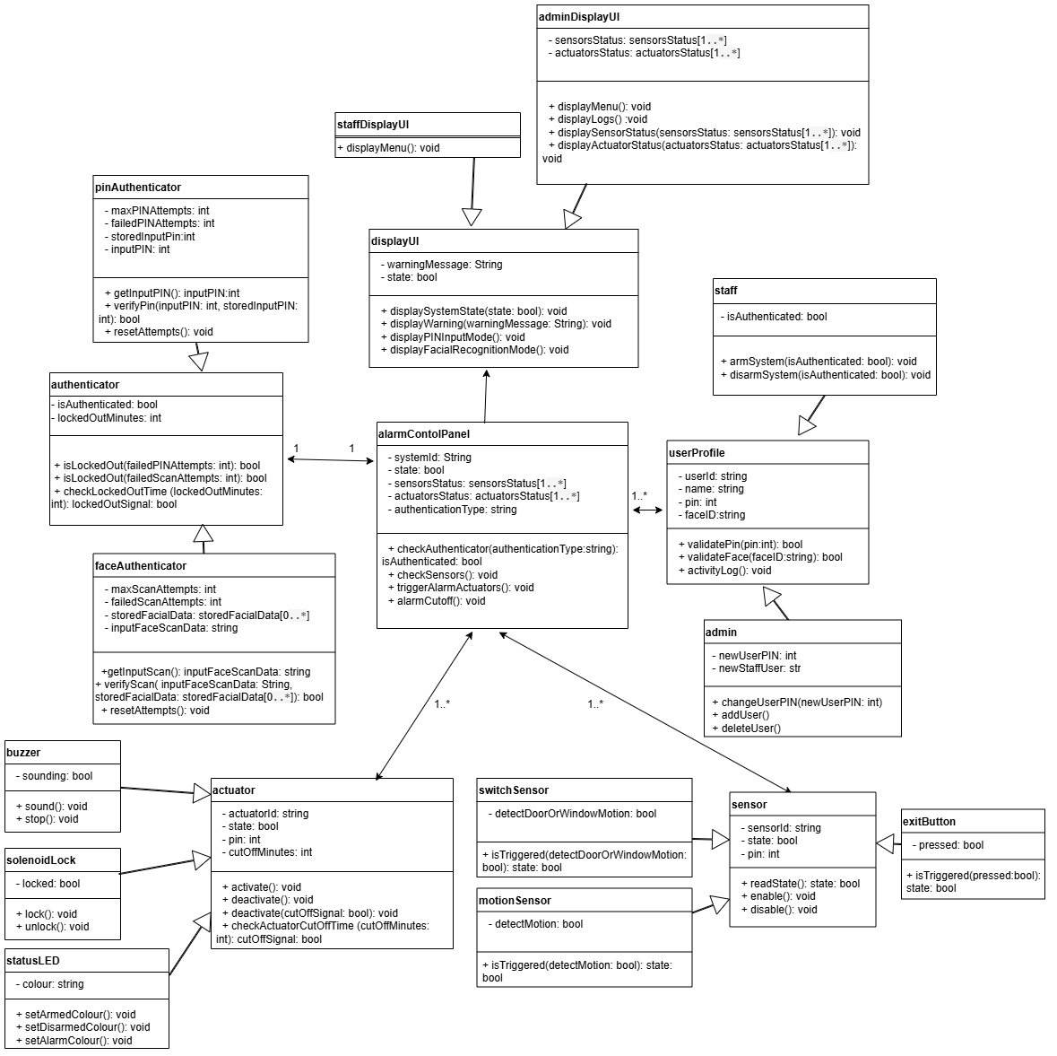
The main changes that we needed to make as a response to the given feedback was to:

1. Add constructor methods to the classes.

2. specify the multiplicity of sensors and actuators.

3. Add more relevant attributes and remove any unnecessary methods/attributes.

When designing our new and improved UML diagram we made sure every method had its constructor method written down. All multiplicities are now covered as well for our specific system (however if we were to scale our system most would go from a ‘1’ to a ‘1..*’ multiplicity). We decided to remove the UI and authentication classes as we decided to implement these within our system on python rather than arduino/c++.

Our new diagram after having made the necessary changes (on the next page)

